Topic: Computer Programming

Lesson 1: Programming Basics

|  |  |
| --- | --- |
| Aim | 0b •ectives |
| Master communication skills and competences in computer programming, programming paradigms and the essence of object-oriented programming | At the end of this lesson, students will be able to:   * define the concept of computer programming * describe the main programming paradigms * state characteristics of different programming languages * understand the concept of object-oriented programming * discuss and present findings in pairs and small groups * write a summary based on different media |

I. Lead-in

l. Share your opinion on the questions with a groupmale.

1. What is computer programming?
2. What is a programming language?
3. What is a computer program?
4. Can you program? If yes, share your experience.
5. Is it difficult to learn to code?
6. What programming languages are you going to learn? Why?
7. What is the best way to learn programming languages?

2. Consider the bar chart illustrating the most in-demandprogramming languages for 2023 based on Linkedln job postings in the USA and Europe and say why particular programming languages are more popular today than the others.

JavaScript

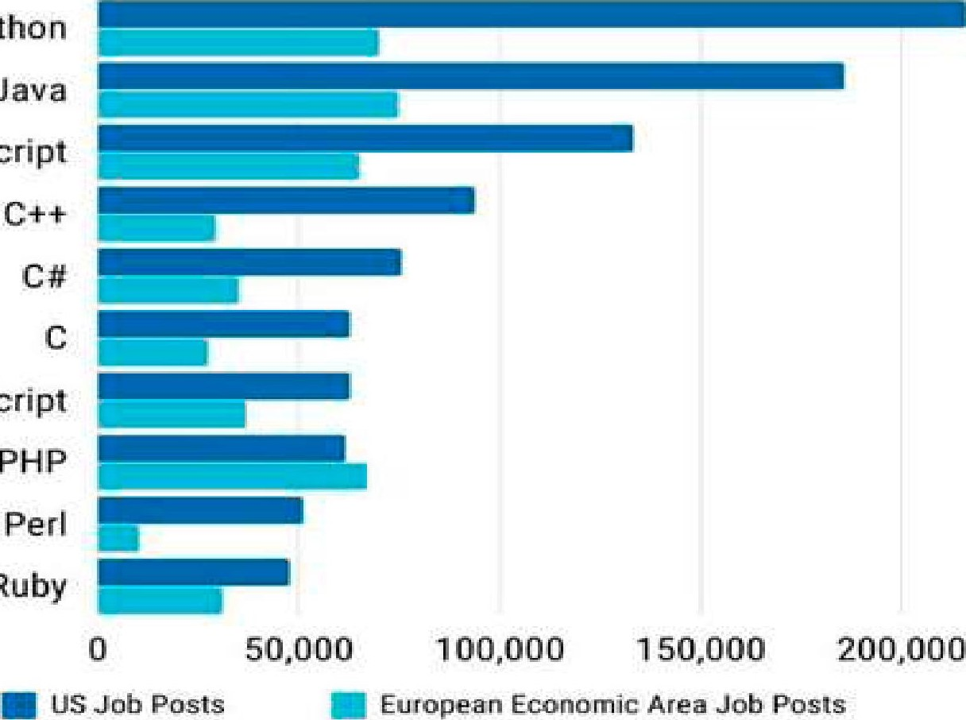

python

Java

Ruby

TypeScript

250$000

Il. Vocabulary Focus

l. Match the words related to programming on the left with the definitions.

|  |  |
| --- | --- |
| 1. Instruction 2. Sequence 3. Self-contained 4. Statement 5. Syntax 6. Language | 1. a single line of code that performs a specific task. 2. having everything that is needed and vitally important within itself. 3. the order in which the statements are executed. 4. the set of rules that defines the combinations of symbols. 5. a system of notation for writing computer programs. 6. a single operation of a processor |

1. Watch lhe first parl Q/ lhe online lecture "Software Development Tutorial The Fundamentals ofProgramming" [44] (from 0:01 till 2:52) and complete the facts with the missing words or word combinations.

l. A computer program is .

* 1. Each instruction is .
  2. The art of programming is .
  3. The sequence here is .
  4. With programming we are .

1. Watch the second part of the online lecture (from 2:52 till the end) and match the beginnings of the statements with the endings.

|  |  |
| --- | --- |
| 1. In programming languages we write 2. Statements in programming languages use  3.  Most programming statements are 4. What words, numbers, and punctuation you use  5. Understanding the rules of each  Ian ua e is | 1. words, numbers, and punctuation to express one thought, one individual piece. 2. these instructions by writing what are called statements. 3. understanding the syntax of a programming language. 4. pretty short, just a few words.   e de ends on the ro rammin Ian ua e |

1. Computer programming involves a broad set of activities. Complete the passage with the words and word combinations in the box to learn more about them.

testing; problem statement; output; scope; assumption; supply; programmers; coding; manipulated; encompasses

Computer programs are developed by computer 1) or software engineers. Computer programming 2)a broad set of activities that include planning,



3) testing, and documenting. Most programmers participate in all of these phases of program development, but focus on the coding process. Software engineers tend to focus on designing and 4) activities.

The programming process begins with a(n) 5)  that helps you clearly define the purpose of a computer program. In the context of programming, it determines certain elements that must be 6)to achieve a goal. A good problem statement for a computer program has three characteristics: it specifies any assumptions that define the 7)of the problem; it clearly specifies the known information; it specifies when the problem has been solved.

In a problem statement, a(n) 8)is something you accept as true in order to proceed with program planning. The known information in a problem statement is the information that you 9)to the computer to help it solve a problem. After identifying the known information, a programmer must specify how to determine when the problem has been solved. Usually, this step means specifying the 10)you expect.

1. A programming paradigm refers 10 a way of conceptualising and structuring lhe tasks a computer performs. Study the table to learn about the most popular programming paradigms and match each type with the description below. Name the programming languages belonging to each paradigm.

|  |  |  |
| --- | --- | --- |
| Paradi m | Ke conce t | Pro ram |
| Procedural | command | Sequence of commands |
| Functional | function | Collections of functions |
| Logical | predicate | Logic formulas: axioms and a theorem |
| Object-oriented | object | Collections of classes of objects |

* 1. It formulates programs as a series of objects and methods that interact to perform a specific task.
  2. It employs functions as the main driving force behind the development.
  3. It is built around the idea that programs are sequences of instructions to be executed.
  4. It has its foundation in math logic so program statements express facts and rules about problems within a system.

1. To write instructions programmers use different programming languages which are described below. Before reading about them, complete the following sentences. Then read the abstract and check your ideas.
   1. The programming language that uses just Os and Is is called a(n)



* 1. The programming language utilising simple English words is called a(n)



* 1. is a program written in one of the high-level languages.
  2. A program written in a high-level language must be interpreted into before the computer will read and process it.
  3. Theis the program produced when the original program has been converted into machine code.
  4. is a program that converts a high-level language into machine code.
  5. A program designed to perform a specific task is called a(n)

Thousands of different programming languages have already been created, with many more being created every year. Before 1952, the only available programming language was machine language, now called a low-level language, that consists of nothing but Os and Is with which the computer works. In 1952, a new low-level programming language called assembly language was introduced. It operates with short letter codes that stand for specific machine operations. A program called an assembler then translates these codes into machine language to be executed. In the 1960s, high-level programming languages emerged, and now programmers can use simple English words and familiar mathematical expressions to code.

A program written in one of high-level programming languages is often called a source program, and it can't be directly processed by the computer until it has been compiled, which means interpreted into machine code. The program produced after the source program has been converted into machine code is referred to as an object program. This is done by a computer program called the compiler, which is unique for each computer. When a program written in one of the high-level languages is designed to do a specific task such as calculate a company's payroll, it is called an application program.

1. A computerprogram must be tested to ensure that it works correctly. When a program does not workproperly, it is usually the result ofa syntax, logic, or runtime error. Match each type oferror with the description.

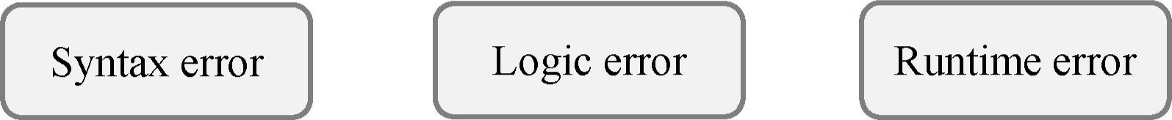

* 1. It occurs when a program is executed and can result from instructions that the computer can't execute.
  2. It occurs when an instruction doesn't follow the grammar of the programming language.
  3. It's a type of runtime error in the coherence and design of a program. It can be caused by an inadequate definition of the problem or an incorrect formula for a calculation.

1. Complete the concept map and summarise the facts about computer programming. Report your ideas to the group.

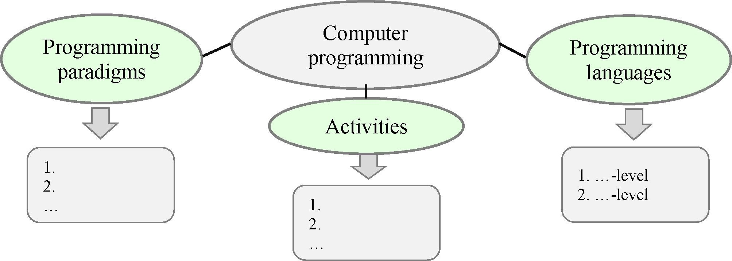

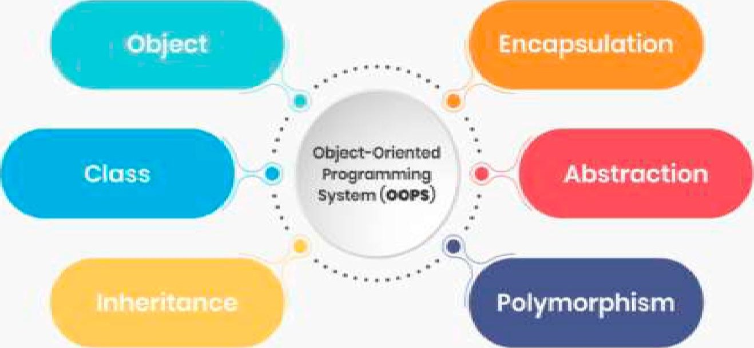Ill. Language Box

l. Look at the diagram on the right that illustrates the main concepts of objectoriented programming (OOP). Can you define or explain each ofthem?

1. Look al the notions related 10 OOP and identify which descriptions correspond 10 them.

|  |  |
| --- | --- |
| l. Object   1. Class 2. Instance 3. Template 4. Method 5. Encapsulation 6. Abstraction 7. Inheritance 8. Polymorphism | 1. It is the mechanism of basing an object or class upon another object or class, retaining similar implementation. 2. It is the concept of object-oriented programming that "shows" only essential attributes and "hides" unnecessary information. 3. It is a specific realisation of any object. 4. It binds data and its related methods together within a class. It also protects the data by making fields private and giving access to them only through their related methods. 5. It is a template for a group ofobjects with common characteristics. 6. It is the ability of an object to take on many forms. 7. It is a blueprint or formula for creating a generic class. 8. It is a unit of data that represents an abstract or a real-world entity. 9. It can modify a class state that would apply across all the instances of the class |

1. Complete the sentences with the words in the box. Each gap isfollowed by a synonym for the missing word.

instance; entities; attributes; variable; pillars

* + 1. An object can be defined as a data field that has unique(characteristics) and behaviour.
    2. Object-oriented programing allows programmers to think of software development as if they are working with real-life(objects).



* + 1. There are four(main principles) of object-oriented programming: Encapsulation, Abstraction, Inheritance, and Polymorphism.
    2. Object is a(n)(example) of a class.



* + 1. The process of encapsulation states that classes cannot communicate or change along with any particular(parameter) and function of an object.

1. Read the abstract "The Main Principles of OOP" below and answer the following questions.
   1. What is the main idea of OOP?
   2. How does OOP treat software development?
   3. What is the difference between Object and Instance in OOP?
   4. What can Method do? What activates Method?
   5. What are the main principles of OOP?
   6. What do Abstraction and Encapsulation have in common?
   7. What does Inheritance help avoid?
   8. What does Polymorphism allow to do?
   9. What are the main benefits of OOP?

# The Main Principles of OOP

Object-oriented programming is one of the main programming methodologies, which is based on the idea that a program is a cluster of objects, each belonging to a certain class and the classes build up an inheritance hierarchy. OOP model organises software design around data, or objects, rather than functions and logic. An object can be defined as a data field that has unique attributes and behaviour.

Object-oriented programing allows programmers to think of software development as if they are working with real-life entities. In your everyday life, people have the knowledge and can do various tasks. In OOP, objects have fields to store knowledge, state, data and can do various methods. Before diving into the four pillars of OOP, there are some basic terms to go over.

Object. The instance of a class. It's the working entity of a class. It's a unit of data that represents an abstract or a real-world entity.

Class. This is the model or standard about the capability of what an object can do. It is a template for a group of objects with common characteristics.

Method. It is a segment of code that defines an action. It can modify a class state that would apply across all the instances of the class.

Message. It activates Method.

Instance. It is like Object, however, within specific realisation.

Now let's jump into the four pillars of object-oriented programming: Encapsulation, Abstraction, Inheritance, and Polymorphism.

Encapsulation. Diverse objects that are present under one program can automatically communicate with each other. If the developer wishes to stop this interaction, they will encapsulate every object individually in the form of classes. The process of encapsulation states that classes cannot communicate or change along with any particular variable and function of an object.

Abstraction. Abstraction is just like the extension of encapsulation as it can hide some properties and methods from being shared with outer code for making the interface of the object easy to understand. Developers specifically make use of Abstraction for different beneficial causes. In short, we can say that Abstraction helps in isolating the impact of changes made on the code for securing the inside code if something wrong happens and the particular change will only affect the present variables, not the whole outer code.

Inheritance. Inheritance is the process of extending the existing code functionality for removing the repetitive coding work. The elements of HTML code contain a text box, a checkbox and a select field with some properties that are common with particular methods. In this, there is no need of redefining all the properties and methods for each HTML element as you can define all of them at once in a general object. Giving a name to the object like "HTMLElement" will help other objects inherit all of its properties and methods and you can avoid the unnecessary work of repetitive coding.

Polymorphism. Polymorphism means "one name many forms" that allows developers to provide multiple elements depending on the object type. This will permit developers to redefine the whole work and define how it can be done by updating the parts in which it was previously performed. Polymorphism terms are known as "overriding" and "overloading".

This approach to programming is well-suited for programs that are large, complex and actively updated or maintained. The organisation of an object-oriented program also makes the method beneficial to collaborative development, where projects are divided into groups. Additional benefits of OOP include code reusability, scalability, and efficiency. Even when using scalability - the ability of microservices, developers should continue to apply the principles of OOP. a system to grow larger

1. Identify the parts of the text in Task 4 the additionalfacts (a—g) belong to.
   1. Private: Data that can only be accessed within the class.
   2. Protected: Data that can only be accessed within the class, and its subclasses.
   3. Public: Data or functions (methods) which can be accessed outside the class.
   4. It gives us a way to use a class exactly like its parent so there is no confusion with mixing types. This being said, each child subclass keeps its own functions/methods as they are.
   5. It is the process of selecting data from a larger pool to show only the relevant details to the object.
   6. It is accomplished when each object maintains a private state, inside a class. Other objects cannot access this state directly, instead, they can only invoke a list of public functions. The object manages its Explicitly — a way that own state via these functions and no other class is clear and exact can alter it unless explicitly allowed.
   7. It is the ability of one object to acquire some or all properties of another object.
2. Watch the video "Object-Oriented Programmmg" [38] devoted to understanding the difference between OOP andprocedural code explained through cooking and mark the statements as true orfalse. Correct the false ones.
   1. Object-oriented paradigm is very popular and widespread today.
   2. OOP is always beneficial.
   3. Procedural programming offers a straightforward approach.
   4. It's easy to present simple programs in terms of object-oriented approach.
   5. Object-oriented code allows to create several mini programs where each object contains its own data and logic.
   6. The end result ofprocedural approach and object-oriented one is not always the same.
   7. 00 approach is better than procedural one.
   8. Code reusability is one of the main pluses of object-oriented paradigm.
   9. Logic and mctional programming languages are used today mainly for creating web, mobile and desktop apps.
3. Watch lhe video again and match [he beginnings of lhe sentences (1 7) with the appropriate endings (a—g).

|  |  |
| --- | --- |
| l . In procedural code, the program is 2. Programmers have a tendency to write code in this procedural manner because 3. Instead of writing a single large program, my object-oriented code is 4. We can talk about and use these programmed objects   1. One ofthe main advantages of using an object-oriented approach is 2. Object orientation is referred to 3. Multiple paradigms mean you can | 1. it's easy to think of simple programs in terms of sequential steps. 2. similar to objects in the real world. 3. written as a long series of operations to execute. 4. code reusability. 5. use them to write code in an objectoriented way or in a procedural way. 6. split apart into several self-contained objects. 7. as a programming paradigm supported by many languages |

1. Complete the table and get ready to speak about OOP. Work with a groupmate.

|  |  |
| --- | --- |
| Ob'ect vs Class in OOP |  |
| Method vs Message in OOP |  |
| Main concepts of OOP |  |
| Benefits of OOP |  |
| Pitfalls of OOP |  |
| Suitable tasks for OOP |  |

IV. Decision Bank

l. Each programming language has its recognisable logo. Here are the logos of the most popular object-oriented languages. Name them and say what you know about each of them.

 a)  b) c) 

1. Watch lhe video "What Is Python? " [54] and complete the ideas.
   1. Python is .
   2. People from different disciplines use Python for
   3. You don't have to be a software developer to .
   4. With Python you can solve .
   5. Python makes a lot of trivial things .
   6. It's cross platform which means you can .
   7. It has a large ecosystem of .
2. Read about the top three most popular object-oriented languages today. List their main features. Which one would you learn first? Why?

Java is a general-purpose programming language that is class-based, objectoriented, and designed to have as few implementation dependencies as possible. It allows developers to write once and run anywhere which means the compiled Java code has all the capabilities to run on every single platform that has the support of Java without extra recompilation.

|  |  |
| --- | --- |
| Benefits of Java | Drawbacks of Java |
| Java is an easy-to-learn language with clear syntax to understand.  It is platform-independent, so you can write once and run anywhere. Java is a highly secure language.  The multithreading feature allows us to write the program and perform multiple    tasks simultaneously.  A portable platform that has no implementation-dependent features. It is a high performing, interpreted  Ian ua e | It's slow and has poor performance because of the compilation and abstraction level of virtual machine. It offers an unattractive look and feel of the GUI.  Java has no backup facility.  It always requires a huge memory space.  The codes of Java are verbose and complicated |

Python is an interpreted, general-purpose, high-level programming language. The design philosophy of Python focuses on code readability with the use of significant indentation. Its language constructs and object-oriented approach allow developers to write clear code for small and large-scale projects.

|  |  |
| --- | --- |
| Benefits of P hon | Drawbacks of Python |
| Python is easy to code and learn.  It is a free and open-source language that you can easily get from the official website.  Python is the best option for crafting graphical apps.  Python is a high-level language with extensible feature support.  It is an inte rated and ortable Ian ua e | The speed of Python is slow as compared to C and C++.  It does not provide a good choice for mobile development.  You should avoid selecting Python in memory-intensive tasks.  It has limitations with database access. Python gives more runtime errors and that's wh re uires focusin on testin |

Ruby is an interpreted, general-purpose, high-level programming language. It can be dynamically typed and makes use of garbage collection. Also, it provides full support for programming paradigms that covers object-oriented, procedural, and functional programming. The language is specially focused on faster software development and that's why it's called a "startup technology".

|  |  |
| --- | --- |
| Benefits of Rub | Drawbacks of Rub |
| Ruby is a time-efficient language that reveals its potential in a very short time. It has many various helpful tools and libraries.  It has a strong and active community.  Rub has a strong adherence to standards | Ruby is less flexible in managing simple tasks.  It provides no support for continuous updates and evolvement.  The performance time of Ruby is rather slow especiall when the project is big |

1. Choose a programming language and get ready to describe its main features, pluses and minuses, sphere of implementation. Work in groups of three or four people. Then report your ideas to the group.

V. Conclusion Worksheet

|  |
| --- |
| LEARn ro codE |

Coding is an extremely useful skill to possess nowadays. There are an increasing number of businesses that rely on computer code, not just those in the technology sector. A person who learns how to code will have the advantage in life with more employment opportunities available to them in the future, no matter which industry they decide to enter whether it be in the technolov sector, finance, retail, health or other. This is an important reason why coding should be learnt.

Imagine you were asked to persuade teenagers who are choosing their career path to learn coding. Make a short presentation considering the following questions.

v/ What is coding in simple terms and how does it work? v/ What are the ways to write a code? v/ Why is it important to learn to code?

v/ What is the most suitable age to start learning to code? v/ What are the benefits of coding?

v/ Why is coding important for the future?

'VI. Web Search

Explore the resources in the list to obtain additional information on computer programming, including OOP. Report yourfindings in writing.



https://sphero.com/blogs/news/ http://www.cs.ucf.edu/—leavens/ https://www.educative.io/blog/ coding-concepts ComS541Fa1197/ object-oriented-programming hw-pages/paradigms/major.html

Ml. Revision Point

l. Read the abstract "Encapsulation " and translate it into Belarusian or Russian. Use a dictionary ifnecessary.

# Encapsulation

In object-oriented computer programming languages, the notion of encapsulation refers to the bundling of data, along with the methods that operate on that data, into a single unit. Many programming languages use encapsulation frequently in the form of classes. A class is a program-code-template that allows developers to create an object that has both variables (data) and behaviours (functions or methods). A class is an example of encapsulation in computer science in that it consists of data and methods that have been bundled into a single unit.

Encapsulation may also refer to a mechanism of restricting the direct access to some components of an object so users cannot access state values for all of the variables of a particular object. Encapsulation can be used to hide both data members and data functions or methods associated with an instantiated class or object.

Encapsulation in programming has a few key benefits. It hides data: users will have no idea how classes are being implemented or stored; all that users will know is that values are being passed and initialised. It gives more flexibility: enables you to set variables as read or write-only. It's easy to reuse: it's easy to change and adapt to new requirements.

1. Complete the sentences with the words in the box.

language; high-level; instructions; syntax; aradi ms; com iler; develo ments; low-level

* 1. A computer program is a set of
  2. A program that converts a high-level language into a machine code is called
  3. Programming include procedural, event-driven, and declarative.
  4. Omitting a keyword, such as THEN, or required punctuation, such as a period or using incorrect punctuation are commonerrors.

language includes commands specific to a particular CPU, while a language uses commands, words, and grammar based on human languages.

* 1. C and C++ remain popular today for system and application software
  2. Objective-C is the programming used to develop iPhone and iPad apps.

1. Choose the options from the ones given in italics to make true sentences.
   1. The abbreviation 00, which stands for object-oriented, is used to describe a programming trend/paradigm as well as a variety of programming languages.
   2. In 00 programming, a class is a template for a group of objects with similar methods attributes.
   3. The process of producing new classes with public inherited attributes creates a class hierarchy that includes a superclass and subclasses.
   4. A concept called inheritance polymorphism allows programmers to create a single name for a procedure that behaves in unique ways for different classes.
   5. Procedural Declarative programming focuses on a step-by-step algorithm that instructs the computer how to arrive at a solution.
   6. If you can envision a problem as a set of objects classes that pass messages back and forth, the problem is suitable for the 00 approach.
   7. A segment of code that defines an action and can modify a class state is a method message.
2. Get ready to speak on the topics below and assess your performance according to the following scale.

|  |  |  |
| --- | --- | --- |
| Comprehensive | Rather confident | Limited |

* + - Computer programming and the activities it involves.
    - Programming paradigms.
    - The types of programming languages.
    - Object-oriented programming.
    - Programming languages in demand.

# Lesson 2: Artificial Intelligence

|  |  |
| --- | --- |
| Aim | 0b •ectives |
| Master communication skills and competences in artificial intelligence and its subsets and issues related to game programming | At the end of this lesson, students will be able to:   * explain the essence of Artificial Intelligence * define the difference between Artificial Intelligence, Machine Learning and Deep Learning * state the difference between Virtual and Augmented Realities * list the components of game development * present and discuss findings in pairs and small groups * write a summ based on different media |

I. Lead-in

l. Look al the pictures. Consider what technology they have in common and how your life is impacted by it.

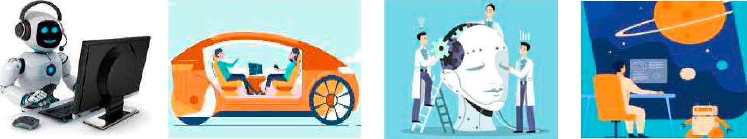

2. Share your opinion on the questions.

1. Computers get faster and better every year. Is it just a matter of time before they become more intelligent than humans?
2. Where are artificial intelligence (Al) apps used in your daily life today?
3. What are the latest advances in the sphere of game programming?

Il. Vocabulary Focus

l. Look at the word cloud with the target vocabulary of this lesson on the right below andfind the terms to match the definitions.

1. It describes algorithms that analyse data with a logic structure similar to how a human would draw conclusions.

2. It is a machine learning technique that teaches computers to learn by example.

1. The use of data, statistical algorithms and machine learning techniques to identify the likelihood of future outcomes based on historical data.

|  |  |
| --- | --- |
| that typically require | neural network |
| human intelligence. | predictWe analyticsaugmented |

|  |  |
| --- | --- |
| 5. It's a simulated experience, | gaming  recognillon platf speech ormrecognition |
| it can be similar to or totally different from the real | artificial intelligencedeep big learningdata |
| world. | di9ital assistant |
| is the ability of a machine or program to | machine learnin9 reality |

1. A branch of computer science concerned with building smart machines capable of performing tasks

identify words spoken aloud and convert them into a readable text.

1. It's a branch of artificial intelligence based on the idea that systems can learn from data, identify patterns and make decisions with minimal human intervention.
2. It is an enhanced version of the real physical world that is achieved through the use of digital visual elements, sound, or other sensory stimuli delivered via technology. 9. It is a computer system specially made for playing video games.
3. It is a series of algorithms that endeavours to recognise underlying relationships in a set of data through a process that mimics the way the human brain operates.
4. It represents a set of methods for detecting and analysing images to enable the automation of specific tasks such as identifying places, people, objects, etc. within an image.
5. It is the newly vast amount of data that can be studied to show patterns, trends, and associations.
6. Machine Learning (IVIL) is a subset ofAl. It helps computers learn without direct instructions. Distribute the characteristics between the two technologies.

|  |  |  |
| --- | --- | --- |
| Artificial Intelligence |  | Machine Learning |

* 1. It enables a machine to simulate human behaviour.
  2. Its goal is to make a smart computer system like humans to solve complex problems.
  3. Its goal is to allow machines to leam from data, so that they can give accurate output.
  4. It's a subtechnology which allows a machine to automatically learn from past data without programming explicitly.
  5. With the help of it we make intelligent systems to perform any tasks like a human.
  6. With the help of it we teach machines with data to perform a particular task and give the accurate result.
  7. The main applications are Online recommender system, Google search algorithm, Facebook auto friend tagging suggestions.
  8. The main applications are Siri, Online game playing, intelligent humanoid robot.
  9. It has a limited scope.
  10. It has a very wide range of scope.

1. Study the key attributes of machine learning and deep learning (DL). Work out the meanings of the words in bold. Summarise how IW and DL differ.

|  |  |  |
| --- | --- | --- |
| Attributes | Machine Learnin | Dee Learnin |
| Definition | It is a sub-branch of artificial intelligence; it allows the machines to train with diverse datasets and make predictions basin  on their ex eriences | It is a subset of machine learning with the constant focus on achieving greater flexibility by contemplating the whole world as a hierarch of conce ts |
| Working mechanism | It utilises automated algorithms to predict the decisions for the future and to model the functions based on the data it receives | Neural networks help in interpreting the features of data and their relationships in which important information is processed throu h some sta es |
| Management | All the analysis is managed by analysts to evaluate different variables under the multiple datasets usin ML al orithms | All the algorithms are self-directed after the implementations for result fetching and data analysis |
| Practical examples | Practical examples are speech recognition, medical diagnosis, statistical arbitrage, classification, prediction, and extraction | Practical examples are virtual assistants, shopping and entertainment, facial recognition, translations, pharmaceuticals, and vision for driverless vehicles |
| Data points | Data points are used for analysis usually numbered in thousands | Data points are used for analysis usually numbered in millions |

1. Today the terms artificial intelligence, machine learning, and deep learning are

Q/ten confused. Look at the diagram and identify which of the three the following features refer to.

* 1. It provides the ability to automatically learn and improve from experience without being explicitly programmed.
  2. 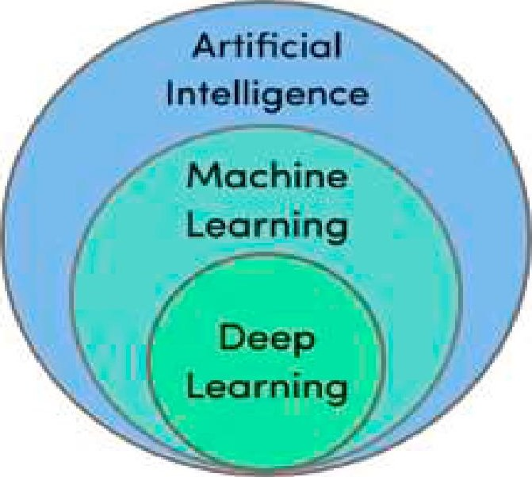It uses the neural networks to analyse different factors with a structure that is similar to the human neural system.
  3. It studies ways to build intelligent programs and machines that can creatively solve problems.
  4. It's a program that can sense, reason, act, adapt.
  5. Its algorithms improve their performance as they are exposed to more data over time.
  6. It learns from a vast amount of data.
  7. It's the study of training your computer to mimic human brains.

1. Machine learning has become a key player in solving problems in various areas due to the rise ofbig data. Match the five V 's ofbig data with the appropriate descriptions.

|  |  |
| --- | --- |
| 1. Volume 2. Velocity 3. Variety 4. Veracity 5. Value | 1. refers to the wide range of data formats; big data may be structured, semi-structured, or unstructured, and can present as numbers, text, images, audio, and more. 2. refers to the amount of data; big data deals with high volumes of data. 3. refers to the quality and accuracy of data. 4. refers to the usefulness that big data can provide for organisations. 5. refers to the rate at which the data is received; big data streams at a high velocity, often streaming directly into memory as opposed to being stored onto a disk |

1. Augmented reality (AR) and virtual reality (VR) are the technologies that either enhance or replace a real-life environment with a simulated one. Read the abstract about them and complete the gaps with the words in the box.

coin; enhanced; immersive; headsets; vision; blend; trackin ; simulated

Augmented Reality (AR) is a perfect l) of the digital world and the physical



elements to create an artificial environment. AR uses computer 2) mapping as well as depth 3) This functionality allows cameras to collect, send, and process data to show digital content appropriate to what any user is looking at. In AR, the user's physical environment is 4) with contextually relevant digital content in real-time.



You can experience AR with a smartphone or with special hardware.



Virtual Reality (VR) is the use of computer technology to create a(n) 5)



environment. It is used in 3D movies and video games. It helps create simulations close to the real world and "immerse" the viewer using computers and sensory devices like 6)and gloves. By simulating as many senses as possible, such as vision,



hearing, touch, even smell, VR is also used for training, education, and science.

VR and AR are two sides of the same 7) AR simulates artificial objects in the real environment, VR creates an 8) artificial environment.



1. Complete the lists ofadvantages and disadvantages with the appropriate derivatives ofthe words in brackets. Guess which type ofreality, AR or VR, they refer to.

|  |  |
| --- | --- |
| Advanta es | Disadvanta es |
| 1. It offerslearning. (individuality) 2. People can share experiences over a long (distant)   1. It creates an  environment.   (interact)   1. It helps you create a realistic world so that the user can  the world. (exploration) 2. It allows users to experiment with environment. (artifice) 6. It offers innovation and improvement. (continue)   7. It provides learning. (immerse) | 1. It features the lack of (private) 2. People start living in the  world instead of dealing with real-world issues. (real) 3. It has a low level of (perform) 4. If somebody did well with tasks, there is still no guarantee that a person is doing well in the real world. (simulate) 5. Extreme  with technology can lead to major healthcare issues such as eye problems and obesity. (engage) |

1. Share your opinion on the questions with a groupmate.
   1. What is the difference between Al, NIL and DL?
   2. Why is Big data important?
   3. How can AR and VR change the physical environment?
   4. What are the pros and cons of AR and VR?
   5. Is Al a threat or an opportunity for your future career?

Ill. Language Box

l. Watch the video "What Is Artificial Intelligence? " [51] and mark the statements as true orfalse. Correct the false ones.

1. Thanks to books and movies, each generation has formed its own fantasy about robots that can entertain people.
2. When you order a pizza using a virtual assistant Alexa or browse movie suggestions using Netflix help centre, you are interacting with artificial intelligence.
3. It is clear that a person commands Al.
4. Machines seem like they have human intelligence thanks to a computer science area Al.
5. Al allows a computer only to drive a car.
6. Dartmouth professor John McCarthy invented the term "artificial intelligence' in 1965.
7. Al is a science to make machines that can use language, form abstractions and concepts, solve a variety of problems.
8. Watch the video again and complete the sentences with the missing words.
   1. Al is designed, so you don't realise there's a computerthe shots.
   2. The term "artificial intelligence" was first  by Dartmouth professor John McCarthy.
   3. And now thanks to  in processing speeds, computers can actually make sense of all this information more quickly.
   4. Tech giants and  capitalists have bought into Al and are infusing the market with cash and new applications.
   5. That means Al can manifest itself in many different ways. Let's down the options.
   6. Natural language processing makes these bots a bit more
9. Complete the sentences (Ä) below with the synonyms to the words in bracketsfrom the box.

intelli ent; ethical; bunch; mimic; intervention; assum tion; forecast; reca

* 1. We'll just(resume) briefly on what we did.
  2. The company(foresee) reduced profits.
  3. Your arguments are faulty because they are based on erroneous(hypothesis).
  4. There is still some hope that the economic blockade will work and make military (intrusion) unnecessary.
  5. Transplantation of organs from living donors raises (righteous) issues.
  6. She can(replicate) the various people in our office.
  7. He is highly (bright) person who can think outside the box.
  8. He left a huge (pile) of papers in his office.

1. Read the abstract "The Rise ofArtificial Intelligence " and get ready to answer the questions.
   1. What is Al essentially?
   2. What things can a machine program do with Al?
   3. What is the basic difference between Al and W?
   4. Is Al a part of our lives? Give the examples of intelligent gadgets that we use.
   5. What is the future of Al? Give the examples of using Al in future.

# The Rise of Artificial Intelligence

The term "artificial intelligence" dates back to 1956 and belongs to John McCarthy, a researcher who coined the term and defined the key mission of Al as a sub-field of computer science. Basically, artificial intelligence (Al) is the ability of a machine or a computer program to think and learn. The concept of Al is based on the idea of building machines capable of thinking, acting, and learning like humans. There are certain things a machine/computer program must be capable of to be considered Al.

|  |
| --- |
|  |
| RISC or ARTIFICIAL INTELLIGENCE |

First, it should be able to mimic human thought process and behaviour. Second, it should act in a humanlike way — intelligent, rational, and ethical.

Al is not the same as machine learning. Although the two terms are often used interchangeably, they are different. Artificial intelligence is a broader concept, while machine learning is the most common application ofAl. We should understand machine learning as a current application of Al that is focused on development of computer programs that can access data and learn from it automatically, without human assistance or intervention. The entire machine learning concept is based on the assumption that we should give machines access to information and let them learn from it themselves.

Artificial intelligence, in its turn, is a bunch of technologies that include machine learning and some other technologies like natural language processing, inference algorithms, neural networks, etc.

Many people associate Al with the distant future. They incorrectly believe that despite all the buzz around artificial intelligence, the technology is not likely to become a part of their lives anytime soon. Little do they know how many aspects of their lives have already been affected by Al.

What is remarkable (and a little scary) about such assistants is that they continuously learn about their users until the point at which they are able to accurately anticipate users' needs. Spotify, Pandora, and Apple Music are some other touching points between Al and you. These services are capable of recommending music based on your interests. These apps monitor the choices you make, insert them into a learning algorithm, and suggest music you are most likely to enjoy. This particular use of Al is probably one of the simplest among all, but it does a good job helping us discover new songs and artists.

Al is making headway in areas you might least expect it. The current state of artificial intelligence already allows for some basic robot writing. It might be not yet ready to compose in-depth articles or creative stories but does a pretty good job writing short and simple articles like sport recaps and financial summaries. Other examples of artificial intelligence in use today include smart home devices like Google's NEST, self-driving cars like those produced by Tesla, and online games like Alien: Isolation.

Some people claim that Al is still in its infancy. Others assure us that we are only a few years away from Al gaining control over humanity. The truth, however, lies somewhere in between. According to the most trustworthy forecasts out there, Al will outsmart humans at virtually everything in the following 45 years.

Experts predict that within the next decade Al will outperform humans in relatively simple tasks such as translating languages, writing school essays, and driving trucks. More complicated tasks like writing a bestselling book or working as a surgeon, however, will take machines much more time to learn. Al is expected to master these two skills by 2050.

5. Mark the statements as true or false. Correct the false ones. Address Task 4 if necessary.

1. Artificial intelligence is a relatively new field of cognitive science.
2. Al is identical to machine learning.
3. The entire machine learning concept is based on the assumption that we can't give machines access to information and let them learn from it themselves.
4. Al is already capable of composing in-depth articles and creative stories.
5. Intelligent gadgets analyse information and can anticipate users' needs.
6. Al has limited application.

every bright side has a darker version in it, artificial intelligence is nol an exception. Consider some of its disadvantages and complete the gaps with the words in the box. Add any other drawbacks that are not mentioned. Which one is the most serious? Why?

efficiency; crash; addicted; maintenance; replace; automating; interference; bond; re uirements; backdro ; u datin ; ualified

1. High costs of creation. As Al is 1)  every day the hardware and software need to get updated with time to meet the latest 2) Machines demand repairing and 3)  which mean plenty of expenses. Their creation requires huge costs as they are very complex.
2. Making humans lazy. Al is making humans lazy with its applications 4) the majority of the work. Humans tend to get 5) to these inventions which can cause a problem to future generations.
3. Unemployment. As Al is replacing the majority of the repetitive tasks and other works with robots, human 6)  is becoming less which will cause a major problem in the employment standards. Every organisation is looking to replace the minimum 7)  individuals with Al robots which can do similar work with more 8)
4. No emotions. There is no doubt that machines are much better when it comes to working efficiently but they cannot 9)  the human connection that makes the team. Machines cannot develop a 10)  with humans which is an essential attribute when comes to team management.
5. Lacking out of the box thinking. Machines can perform only those tasks which they are designed or programmed to do, anything out of that they tend to 11)  or give irrelevant outputs which could be a major 12)

7. Share your opinion on the questions with a groupmate.

1. How does Artificial Intelligence impact our life today?
2. How could the artificial intelligence technology be used in the future?
3. What are the key advantages of this technology in your opinion?
4. How worried should we be about Al replacing our jobs?
5. What aspects of Al can make it dangerous?
6. Why might some people think that too much technology can cause problems?

IV. Decision Bank

l. Al programming is a highly specialised area Q/ game development, it should be seamless and invisible to the player, but it provides the game with "a brain " that works instinctively and independently based on the individual player 's gameplay. Gaming is one ofthe most widespreadpastimes, share your opinion on the questions with a groupmate.

aficionado

|  |  |
| --- | --- |
| l. What kind of video games have you played? |  |
| 2. Are you a video game aficionado or is it just not your | [e frsje l na deu] |
| cup of tea? | a person who likes, |
| 3. What's the most remarkable or the most memorable game you have ever played? | knows about, and |
| 4. They say that video gamers are isolated loners. Do you | appreciates an |
| agree? Are there any other stereotypes of a gamer? | interest or activity |

1. There are different genres ofvideo games such as simulation, strategy, role-playing, adventure or puzzle. Read each description and decide what genre it corresponds to. Elicit the main features of each genre. Which one would you like to design? Why?
   1. Players in this genre of video games assume the roles of characters in a fictional setting. Players take responsibility for acting out these roles within a narrative, literal acting or through a process of structured decision-making regarding character development. Actions taken within many games succeed or fail according to a formal system of rules and guidelines.
   2. Various riddles can test problem-solving skills, including logic, pattern recognition, sequence solving, spatial recognition, and word completion.
   3. This genre of video games describes a diverse super-category of video games, designed to imitate real world activities. This game attempts to copy different activities from real life in the form of a game for such purposes as training, analysis, prediction, or simply entertainment. Well-known examples are war games and business games imitation.
   4. This is a video game genre in which the player assumes the role of a protagonist in an interactive story driven by exploration and/or puzzle-solving. The genre's focus on story allows it to draw heavily from other narrative-based media, literature and film, encompassing a wide variety of literary genres. Many these games are designed for a single player, since this emphasis on story and character makes multiplayer design difficult.
   5. This genre of video games focuses on skillful thinking and planning to achieve victory. It emphasises planned, tactical, and sometimes logistical challenges.
2. This is the list of the most popular video games. Define what genre in Task 2 they belong to. Discuss what made these games popular with regard to the video game components listed below. Work with a groupmate.

|  |  |
| --- | --- |
| v/ Heavy Rain | The Witcher 3: Wild Hunt/Diab10 |
| Batman: Arkham City | World of Tanks |
| v/ War Thunder | Heroes V |

Art. Normally in video games it can include various things like the game texture, game lighting, 3D modeling of characters / objects, particle systems to create fire, fog, snow

|  |
| --- |
| Characters. It's a fundamental part of any video game. You choose the looks and personalities, how fast they move, what manners and characteristics they should possess |
| Level. All good video games have various degrees that increase the difficulty as time goes on. They can be denoted in games by multiple floors, different buildings, or even different countries and each degree can have many potential paths that eventually lead to the next layer. And such design is a big factor in game development |
| Audio. It is the backbone of video games. That means it should support the game and yet not be too obvious. You have to decide the various sounds in the game world like player sounds, background music, etc. that together create a lifelike and believable video game |

Lighting. It's very important for mood setting. When there's less of it, it's an association with horror games while increased one can denote more adventure or mn games. Also, it can be an important factor in stealth challenges with darker areas providing cover to characters

Story. It can have a linear structure which is relatively easy, or it can even have a nonlinear structure with various plot changes according to the character's actions. The main point is that there should be something interesting to hook your players

1. Imagine you are to design a video game. Consider the genre, game components, technologies. Choose a programming language that you are going to use from the options below. Work with a groupmate. Present your game to the group.

|  |
| --- |
| C++. This language allows you to develop games across various platforms, including Windows, Mac, Linux, Android, and iOS. You need a game engine to create games, and this language is used in numerous 2D game engines and 3D game engines. It is fast, owerful, and flexible |
| Java. This language is widely used by Indie game development companies and for creating mobile games. Many of the world's top mobile games have been developed in this language. Minecraft, Mission Impossible Ill, and Asphalt 6 are just a few popular names you are probably familiar with |
| Unreal Engine. A state-of-the-art engine and editor with photorealistic rendering, dynamic physics and effects, lifelike animation, robust data translation, and much more — on an open, extensible platform |
| Unity 3D. It is the world's most popular game engine. It packs a ton of features together and is flexible enough to make almost any game you can imagine. It's been used to create games like Pokémon Go, Hearthstone, RimWorld, Cuphead, and lent more |
| Lua. It is a simpler, multi-platform language, but highly compatible with more complex languages. It is considered lightweight and easy to learn, and is useful for different types of gaming, as well as web applications and image processing. It's the language behind popular games like Angry Birds and .Age of Conan |

1. Conclusion Worksheet

The Olympic Committee regularly makes changes to the sports program. Imagine that you have been assigned to prepare a report on whether to include e-sports in the program of the Olympic Games or not. Watch the video "E-Sport at the Olimpics " [33], read the comments about e-sports below, summarise all your ideas andprepare arguments for and against e-sports as a part of the Olympics.

v/ "Obviously the physical aspect is less in video games than it is in football, but everything else: strategising, team play, the will to win, the thrill of winning, the fear of losing. It's all the same thing, it's not much different from traditional sports." - RalfReichart, CEO of ESL Gaming v/ "In the digital era, e-sports will not just be established as a major sport, but also the most beloved sport." — Jun Byung Hun, the President of the Korean eSports Association v/ "Watching people play video games isn't like watching people play football. It's like watching people play fantasy football. It is one more step removed from human activity. " — Jimmy Kimmel, American television host v/ "It's not a sport it's a competition. Chess is a competition. Checkers is a competition," - John Skipper, ESPNPresident global sport broadcasting network

1. Web Search

Explore the resources in the list to obtain additional information on artificial intelligence. Report yourfindings in writing.



https ://www.javatpoint.com/difference- https://www.oracle.com https://www.investopedia.com/ between-artificial-intelligence-and- terms/b/big-data. asp machine-learning

1. Revision Point

l. Read the abstract "Machine Learning Methods " and translate it into Belarusian or Russian. Use a dictionary ifnecessary.

# Machine Learning Methods

Supervised learning algorithms are trained using labeled examples, such as an input where the desired output is known. For example, a piece of equipment could have data points labeled either "F" (failed) or "R" (runs). The learning algorithm receives a set of inputs along with the corresponding correct outputs, and the algorithm learns by comparing its actual output with correct outputs to find errors. It then modifies the model accordingly. Through methods like classification, regression, prediction and gradient boosting, supervised learning uses patterns to predict the values of the label on additional unlabeled data. Supervised learning is commonly used in applications where historical data predicts likely future events.

Unsupervised learning is used against data that has no historical labels. The system is not told the "right answer". The algorithm must figure out what is being shown. The goal is to explore the data and find some structure within. Unsupervised learning works well on transactional data. For example, it can identify segments of customers with similar attributes who can then be treated similarly in marketing campaigns. Or it can find the main attributes that separate customer segments from each other. Popular techniques include self-organising maps, nearest-neighbour mapping, k-means clustering and singular value decomposition.

1. Use the words given m capitals at the end of the statements and the suffixes in the box to make new words and complete the gaps.

-ment; -ion; -ive; - • -it ; -ous; -able; -ed

* 1. Many times researchers study some areas to satisfy theirbut as a result new things are invented. CURIOUS
  2. Recent  in machine learning has allowed us to create machines that can compete with humans in some areas. DEVELOP
  3. Engineers can now apply  technological solutions to automatise many tasks that required human input. ADVANCE
  4. Machines are not always and sometimes break down, so we should limit our dependence on them in everyday life. RELY
  5. There are  reasons why we should create artificial intelligence.

NUMBER

* 1. Some people believe that Al is such atechnology that it will change our lives just as the Internet or TV did. TRANSFORM
  2. The  of gunpowder was one of the most significant achievements of the Middle Ages in China. INVENT
  3. Theirwas quickly confirmed, making it the first confirmation of planets outside our Solar System. DISCOVER

1. Mark the statements as true orfalse. Correct the false ones.

l. Story, Characters, Audio, Art, Lighting, Level are the components of a video game.

* 1. The genre of a video game that focuses on skillful thinking and planning to achieve victory is called adventure.
  2. In game platform we define the type of game from mini 2D game, casual 2D/3D game, mid-core 3D game or hardcore 3D game.
  3. With artificial intelligence, when the decisions are taken from the previously gathered information applying a certain set of algorithms the errors are reduced. 5. The term "artificial intelligence" was invented in 1996 by John McCarthy.
  4. The main applications of Al are Online recommender system, Google search algorithm, Facebook auto friend tagging suggestions.
  5. Machine learning is the key to voice control in consumer devices like phones, tablets, TVs, and hands-free speakers.
  6. Augmented reality is used in 3D movies and video games.
  7. Augmented reality is used to enhance both real and virtual worlds.

1. Get ready to speak on the topics below and assess your performance according to the following scale.

|  |  |  |
| --- | --- | --- |
| Comprehensive | Rather confident | Limited |

* + Artificial Intelligence, its usage, advantages and disadvantages.
  + Machine Learning, Deep Learning, Big Data.
  + The difference between Virtual Reality and Augmented Reality.
  + Game programming, genres, components, programming languages.

# Lesson 3: Robotics

|  |  |
| --- | --- |
| Aim | 0b •ectives |
| Master communication skills and competences in robotics basics, types of robots and robotic system technologies | At the end of this lesson, students will be able to:   * state the goals, capabilities and applications of the robotic systems * describe the building blocks of robotic systems and their types * discuss and present findings in pairs and small groups * write a summary based on different media |

I. Lead-in

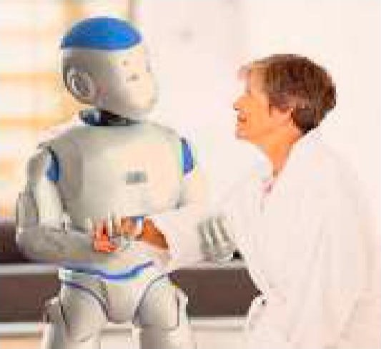l. Share your opinion on [he questions.

1. How are robots better than the human workforce?
2. If you could have a robot, what tasks would you use it for?
3. What threats do robots present to mankind?
4. Would you ever trust a robot to watch your children or walk your dog? Robots are
5. What ideas in the pictures on this page do you support? reflections of

2. Read the most stunning robotics industry statistics. What do they illustrate? What surprised you the most?

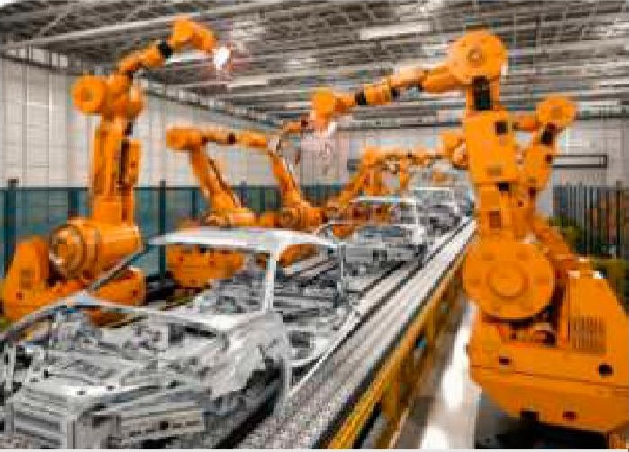v/ Since 2000, around million manufacturing jobs have already been replaced by robots all over the world.

v/ Oxford economics has found that around 1,6 manufacturing employees' jobs are replaced by the installation of each new robot.

v/ Global spending on military robotics will be $16,5

Robots already run most billion in 2025.

of our world v/ The robotics industry employs about 150,000  people worldwide in engineering and assembly jobs.

v/ The robotics industry market projects a growth of $16,78 billion in 2022 to $35,68 billion by 2029.

v/ 88 % of businesses worldwide plan to adopt robotic automation into their infrastructure.

v/ 90 % of businesses worldwide plan to adopt robotic automation into their infrastructure by 2030.

v/ By 2030, robots could potentially take over approximately 20 million manufacturing jobs worldwide.

Il. Vocabulary Focus

l. Match the pictures with the types of robots in the box. Then complete the abstract below with the missing types.

virtual robots; rolling robots; stationary robots; autonomous robots; walking robots; remote-control robots

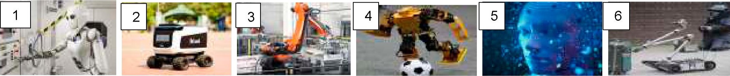

Mobile robots are of two types. l) have wheels to move around. They can quickly and easily search. However, they are only useful in flat areas. 2)have legs and are usually brought in when the terrain is rocky. Most robots have at least four legs; usually they have six or more. Robots are not only used to explore areas or imitate a human being. Most robots perform repetitive tasks without ever moving an inch. Most robots are "working" in industry settings and are known as 3) 4) are selfsupporting or in other words, self-contained. In a way they rely on their own "brains". 5)are guided by a person with the help of a remote control. A person can perform difficult and usually dangerous tasks without being at the spot where the tasks are performed. 6)don't exist in real life. They are just programs, building blocks of software inside a computer.

1. Match the words related to robotics on the left with the appropriate definitions.

|  |  |
| --- | --- |
| 1. Bot 2. Innovation 3. Flip 4. Recognise 5. Companion 6. Adapt 7. Grab | 1. a new method or idea. 2. a person you spend time with. 3. know someone or something because you have seen or heard of them/it before.      1. take hold of something (e.g. an object) suddenly. 2. an informal word for "robot" 3. turn something around. 4. change to suit different uses or conditions |

1. Watch the video "Robot Butler" [41] and choose which ideas in the box are mentioned in it. Explain how they are related to robotics.

resemble a human; Al technology; robotic assistant; unhealthy environment; Bot Handy; machine learning; robotics; industrial robots; home robot; computer science; Bot Care; innovation; humanoid robots; companion

1. Watch the video again and explain what the expressions in bold mean.
   1. you are at the centre of all our innovations. Bot — a computer
   2. Bot1M Care uses Al technology to take care of all the details in your life program that works

little

* 1. becoming an extension of you in the kitchen, in automatically the living room and anywhere else you may need that extra hand
  2. BotTM Handy uses Al to understand objects like a glass cup or ceramic plate, taking note of their shape and materials to work as your trusted partner.
  3. It flips the script on what a robot in your home could look like.
  4. Each of these robots are built with you in mind.
  5. We're hard at work to bring you next-generation innovation with Al as the core enabler for your better tomorrow.

1. Read the article "An Introduction to Robotics ". Complete the table with the key words and word combinations.

|  |  |
| --- | --- |
| Conce ts | Tar et Vocabul |
| Robots |  |
| Robotics |  |
| Robots' com onents |  |

# An Introduction to Robotics

Robotics is an interdisciplinary branch of computer science and engineering that involves the conception, design, construction and use of robots. The objective of the robotics field is to create intelligent machines that can help and assist humans. With the advancements in machine learning, artificial intelligence, and manufacturing processes, the applications of robotics and the demand for robotics engineers is tremendous. Robotics develops machines that can substitute for humans and replicate human actions. Today, robotics is a rapidly growing field, as technological advances continue; researching, designing, and building new robots serve various practical

|  |  |
| --- | --- |
| purposes, whether domestically, commercially, or military.  A robot is a type of automated machine that is programmed to execute specific tasks with little or no human intervention and with speed and precision. Today, industrial robots, as well as many other types of robots, are used to perform repetitive tasks. They may take the form of a robotic | The term ce robot" is derived from the Czech word "robota", which means "forced labour" or "serve" |

arm, robotic exoskeleton or traditional humanoid robots.

Robotic systems are coveted in many industries because they can increase accuracy, reduce costs and increase safety for human beings. In fact, safety is arguably one of robotics' greatest benefits, as many dangerous or unhealthy environments no longer require the human element. Examples include the nuclear industry, space, defense, maintenance and more.

Robots are made up of six major components: a motor of some sort, a sensory system, a movable physical structure, a power supply, a program and a computer "brain" that controls all of these elements. Basically, robots are machines that replicate human behaviour. First of all, almost all robots have motors or actuators that provide the physical power to move the structure. Some robots use hydraulic systems, while others pneumatic or electric motors to facilitate the movement. Another essential component of a robot is a sensory system that gives the robot the information about its surroundings. Important sensor types include light, sound, temperature, contact, distance, pressure, and positioning sensors. Some robots only have motorised wheels or legs, and others have dozens of movable parts (end-effectors), typically made of metal or plastic that perform the actual work and interact with the environment. These may be specialised tools, such as screwdrivers, rivet guns, paint sprayers, grippers, shovels, drills, hammers, cameras, lights, scalpels, etc. These precise tools allow robots to carry out their specific tasks with precision. All robots require a source of power. Almost all robots receive it from electricity but it can take different forms. A robot might be electrically powered, battery powered or solar powered. A robot's programming isn't a physical component, but it's still an essential part of the whole. Humans write computer programs that tell the robot how to do certain physical tasks. Most robots are reprogrammable — to change the robot' s behaviour, you simply write a new program to its computer. Finally, the main component of a robot is the central processing unit (CPU). It acts as the "brain" of the robot as it functions similarly to the human brain. Data comes in through sensors just as information comes to the neurons in your brain through your body's senses, then the CPU interprets it and acts accordingly.

6. Restore the correct order of the letters in the words in the box. Match them with the words in bold in the sentences below to make true statements. Address Task 5 ifnecessary.

chaimne; dtinu sr; erow; mtrsoo; e ssmt; brosot; itnu; rgoms ra; ouhavirbe

1. Robots are machines that replicate human



1. A robot is a computer-controlledthat is programmed to move, manipulate objects, and perform work while interacting with its environment.
2. Robots can be used in the automotivefor the assembly of engines, transmissions, as well as car body painting and welding.
3. Industrial relieve human operators of dangerous, difficult, highly repetitive tasks.
4. The main component of a robot is the central processing  which acts as the "brain" of the robot.
5. A sensorygives the robot the information about its surroundings.



1. Robots need motors or actuators that provide the physicalto move the structure.
2. Robots use either hydraulic systems, or pneumatic or electric to facilitate the movement.
3. Humans write computer that tell the robot how to do certain physical tasks. 7. To understand how robots actually work, distribute the functions (a-m) below between the components ofa robotic system listed in the diagram.

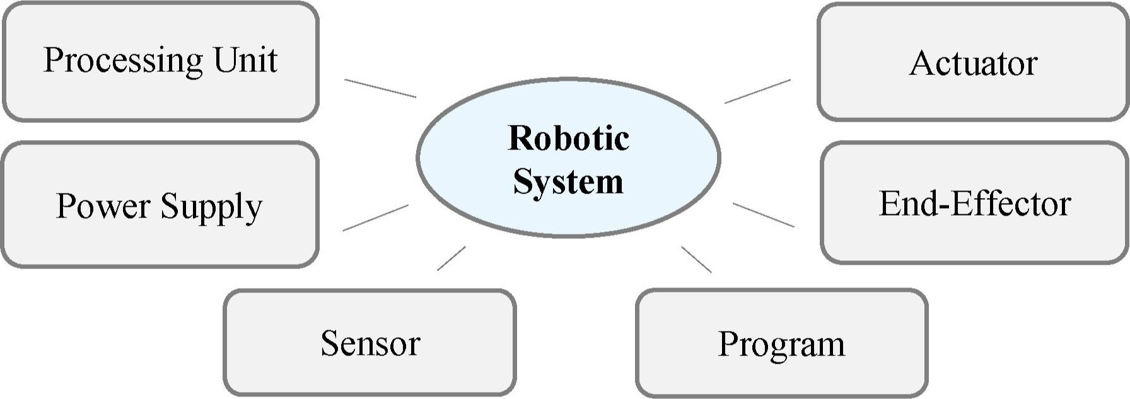

1. They are small motors attached directly to the structure of the machine that facilitate movement.
2. It acts as the "brain" of the robot. In other words, it is the robot component that provides feedback to outside stimuli.
3. It can take different forms. Stationary robots, like those in factories, receive it directly just like any other appliances. Mobile robots typically sport highcapacity batteries while robotic probes and satellites are generally equipped with solar panels for harvesting energy from the sun.
4. They function like muscles.
5. They act as eyes and ears to help a robot take in information about its surroundings.
6. The term refers to the tools aboard the robot — the parts that perform the actual work and interact with the environment or a workpiece. They allow robots to carry out their specific tasks with precision.
7. Robots need energy to function. Almost all robots receive it from electricity.
8. It contains "logic trees" that gather and analyse task and environmental data, and then choose an appropriate response.
9. Robots typically incorporate a wide range of them. Important types include light, sound, temperature, contact, distance, pressure, positioning ones.
10. Some robots use hydraulic systems which use oil to facilitate movement, others  pneumatic motors which use air or electric motors which use electric current and magnets to facilitate movement.

k) It isn't a physical component, but within a robot it provides the logic that drives its behaviours.

l) It functions similarly to the human brain. Data comes in through sensors just as information comes to the neurons in your brain through your body's senses, then this component interprets it and acts accordingly.

m) The examples of such tools might include screwdrivers, rivet guns, paint sprayers, grippers, shovels, drills, hammers, cameras, lights, scalpels, etc.

8. Think of two-three questions related to this section and discuss them with a groupmate.

Ill. Language Box

l. Watch the video "What Is Robotics? " [55] and choose the options from the ones given in italics to make correct sentences.

1. Robotics is the intersection of science, telecommunication engineering and technology.
2. A little bit more common term than robotics is robot machinery.
3. Robots were originally built to handle monolonous repelilive tasks.
4. In 2005 90 % of all robots could be found creating assembling cars in automotive factories.
5. These robots consist mainly of mechanical arms tasked with welding or screwing sanding on certain parts of a car.
6. Today we're seeing an evolved and extended expanded definition of robotics.
7. While the overall world of robotics is expanding, a robot has some contributing consistent characteristics.
8. The mechanical aspect of a robot helps it carry out complete tasks in the environment for which it's designed.
9. A battery, for example, is needed to perform power the machinery.
10. Without with a set of code telling it what to do, a robot would just be another piece of simple machinery.
11. Robots are largely used to perform various variety oftasks and to make human life easy.
12. Watch the video again and complete the sentences with the missing words.
    1. Robotics is the intersection of science, engineering and technology that produces machines called robots that substitute for or 1)human actions.



* 1. A robot is the product of the robotics field where 2)machines are built that can 3)humans or mimic human actions.



* 1. Robots were originally built to handle monotonous tasks like building cars on an assembly line but have since expanded well beyond their initial uses to perform tasks like fighting fires, cleaning homes and assisting with incredibly 4)surgeries.



* 1. Today we're seeing an evolved and expanded definition of robotics that includes the development, creation and use of bots that explore earth's 5)conditions, robots that assist law enforcement and even robots that assist in almost every 6) of healthcare.
  2. All robots consist of some sort of 7)construction.



* 1. Robots need 8)components that control and power the machinery.



* 1. Robots contain at least some 9)of computer programming.
  2. Inserting a program into a robot gives it the 10)to know when and how to carry out a task.
  3. They are widely used in manufacturing, assembly and packing, transport, earth and space 11) surgery, weaponry, laboratory research, and mass production of 12) and industrial goods.

1. Share your opinion on the key ideas. Work in groups of three orfour people.
   1. Robotics is the intersection of several scientific areas.
   2. All robots have some consistent characteristics.
   3. Robots are largely used to perform various tasks and to make human life easier.
2. Read [he article "A Look al Robotics " and define the lopic, aim and slyle of il using the following prompts.

|  |  |
| --- | --- |
| Theme (topic) | * The subject (matter) of this paper is . * The article deals with the topic . * The article touches upon the topic of . * The a er discusses/considers/re orts on |
| Aim (purpose) | * This paper aims at . * The purpose of the article is to give the reader some information on . * The aim of the article is to rovide the reader with |
| Style | - Narrative/descriptive/directive/expository/argumentative |

# A Look at Robotics

Robots are powered through a combination of powerful technologies from the software and hardware world. While advanced engineering and robotics are an obvious must to develop all these robots, the software development community hasn't reached an agreement as to which is the best language to power these robots.

There are various types of languages that you can learn to start working in robotics programming. That's because robots are programmed either by guiding or by off-line programming. The first one refers to how a robot is programmed to be guided from one point to another to cover all of the steps of an operation. Robots programmed like this follow a preloaded set of instructions. Off-line programming implies that the robot can receive instructions through a computer to act according to that input. These kinds of robots are mostly defined by tasks or objectives, so they need to be programmed through a combination of some high-level languages.

C/C++ is considered to be the best starting point for developers new to the robotics industry, these general-purpose languages allow interaction with low-level hardware and provide real-time performance. Also, they are imperative and object-oriented as well as mature, which means that the learning curve will be gentler.

Python is a high-level language that's great to automate, teach, and post-process robotic applications. Its main strength resides in its capability to write scripts that calculate and simulate the entire robot program. This saves you from manually teaching every statement to the robot. This also helps in testing and refining the program's underlying logic. Python can write sophisticated software with fewer lines of code and it has a lot of robotic frameworks that can save you a lot of time.

Java is another popular choice to work on robotics. It offers you a series of APIs (Application Programming Interfaces) that were specifically created for robotics. From command-and-control recognisers to speech synthesisers, there are a lot of components that can be used to build complex robotic systems. Besides, Java is one of the preferred languages to develop artificial intelligence systems, including machine learning algorithms and neural networks that can be crucial for the development of advanced robots.

Though presented as options here, it's best if you see all of these languages as complementary when jumping into the robotics development world. That's because each of these languages has its strengths, weaknesses, and uses, so different applications will call for knowledge in different programming languages. Of course, the more languages you know, the better, as robotic programming uses a lot of different types that take care of different aspects of a robot.

1. Underline the statements in the article in Task 4 that render topical information. Tick the information that you consider additional. Report your ideas to the group.
2. Address the article in Task 4 again and get ready to discuss the following key ideas.

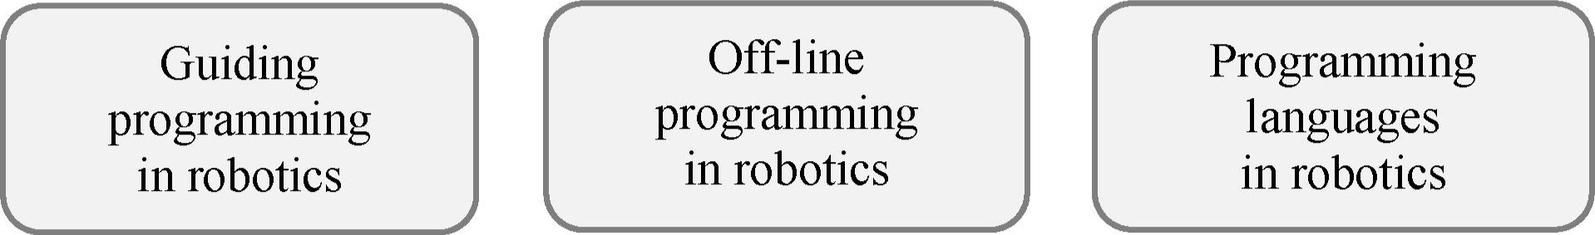

1. Read the statements about robotics. Do you agree with their message? Share your ideas in the group.
   1. Hardware is the most essential components in a robotic system.
   2. Any programming language is suitable for robotics programming.
   3. Robotics is a highly demanded area for IT specialists.

IV. Decision Bank

l. Read the article "Robot Teachers " and share your opinion on the questions.

1. What is the central idea of the publication?
2. What key points are presented in it?
3. What is your opinion of the article?
4. What is your view on the topic identified in it?
5. Would you like to have a robot as a teacher? Why/Why not?

# Robot Teachers

If you think of the jobs, robots could never do, you would probably put doctors and teachers at the top of the list. It's easy to imagine robot cleaners and factory workers, but some jobs need human connection and creativity. But are we underestimating what robots can do? In some cases, they already perform better than doctors at diagnosing illnesses. Also, some patients might feel more comfortable sharing personal information with a machine than a person. Could there be a place for robots in education after all?

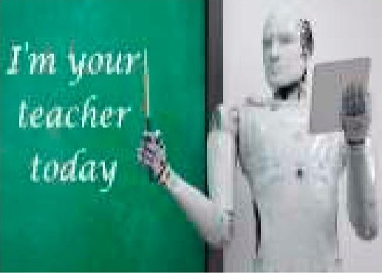British education expert Anthony Seldon thinks so. And he even has a date for the robot takeover of the classroom: 2027. rm your He predicts robots will do the main job of transferring teacher information and teachers will be like assistants. Intelligent robots will read students' faces, movements and maybe even brain signals. Then they will adapt the information to each student. It's not a popular opinion, and it's unlikely robots will ever have empathy and the ability to really connect with humans like another human can.

One thing is certain, though. A robot teacher is better than no teacher at all. In some parts of the world, there aren't enough teachers and 9—16 0 0 of children under the age of 14 don't go to school. That problem could be partly solved by robots because they can teach anywhere and won't get stressed, or tired, or move somewhere for an easier, higher-paid job.

Those negative aspects of teaching are something everyone agrees on. Teachers all over the world are leaving because it is a difficult job, and they feel overworked. Perhaps the question is not "Will robots replace teachers?" but "How can robots help teachers?". Office workers can use software to do things like organise and answer emails, arrange meetings, and update calendars. Teachers waste a lot of time doing non-teaching work, including more than 1 1 hours a week marking homework. If robots could cut the time teachers spend marking homework and writing reports, teachers would have more time and energy for the parts of the job humans do better.

1. Share your opinion on the following ideas.

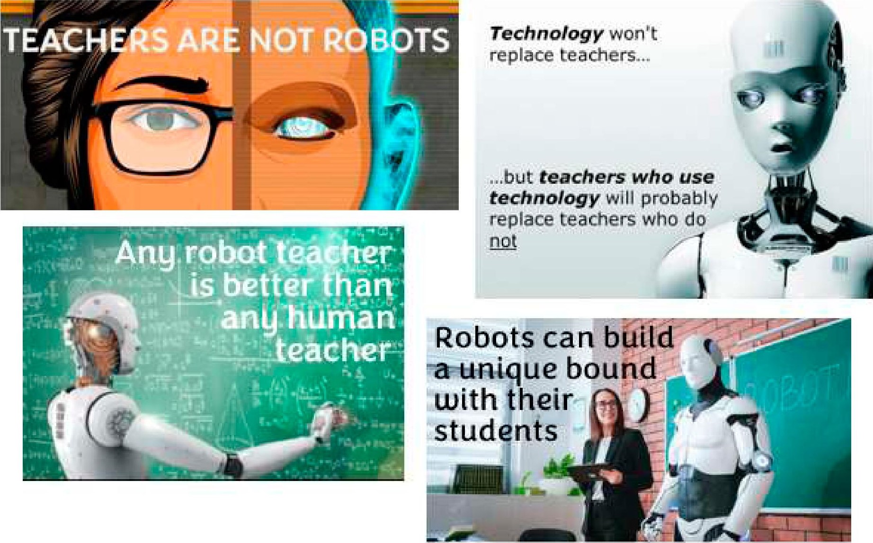

1. Distribute the ideas (a—j) about robots between the two categories. What other options can be added to each category?

|  |  |  |
| --- | --- | --- |
| Advantages |  | Disadvantages |

* 1. They can go to far away planets.
  2. They need a supply of power.
  3. They give us information that humans can't get.
  4. They need maintenance to keep them running.
  5. They work at places 24/7 without any salary and food.
  6. It costs money to make or buy a robot.
  7. They can perform tasks faster, more consistently and accurately than humans.
  8. Most of them are automatic, so they can go around by themselves without any human interference.
  9. People can lose jobs in factories.
  10. They can go far down into the unknown waters and mines where humans can't.

1. Mingle with the groupmates. Discuss the following situations. Give arguments.
   1. Robots are already an integral part of manufacturing in factories. Do you believe that one day there will be little need for humans in manufacturing?
   2. Robots are used to sweep for landmines and bombs. What are the advantages of these practices? Do you see any other uses for robots in combat and police work?
   3. Do you think that one day robots will replace teachers?
   4. What threat do robots present to mankind?
   5. Do you believe robots will ever outsmart people and take over the planet?
   6. Robotic surgery is a method to perform surgery using very small tools attached to a robotic arm and a surgeon controls the robotic arm with a computer. How beneficial do you think this is now and for the future of medicine?
   7. What do you think would happen to the world's economy if robots began replacing people in the workforce?
2. Conclusion Worksheet

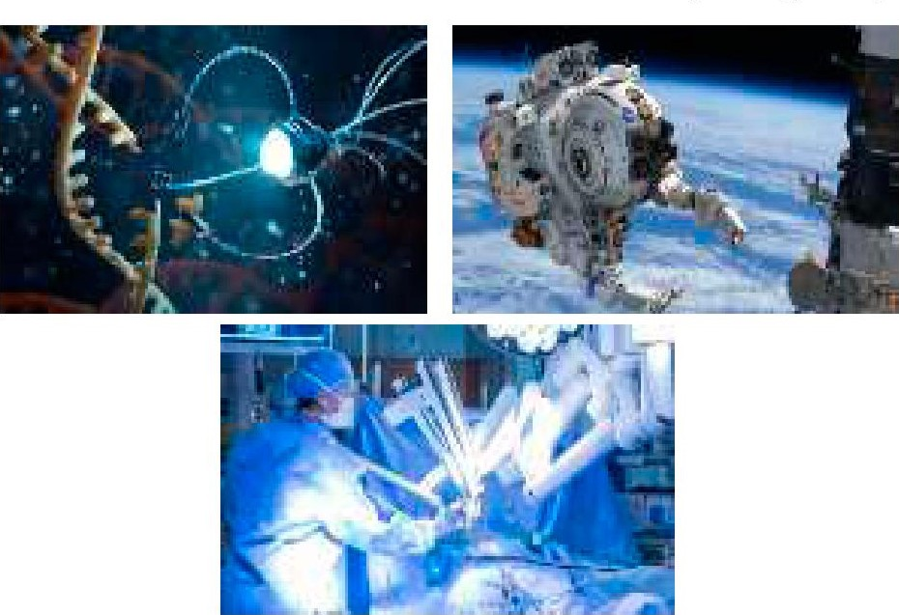Prepare a three-minute report about the most advanced robotic systems used in one of the following areas according to the presentation structure below. Work in groups of three or four people. What can Belarus be proud of?

v/ manufacturing v/ automotive industry (self-driven cars) v/ space/earth exploration v/ medicine v/ security nanotechnology (nanobots) education

|  |  |
| --- | --- |
| Stage | Aim |
| Introduction | communicate the u ose and structure of the talk |
| Bod | cover the main oints of the talk |
| Conclusion | summarise and hi hli ht the si nificance of the talk |

1. Web Search

Explore the resources in the list to obtain additional information on robotics. Report yourfindings to the group.



https://builtin.com/robotics https://whatis.techtarget.com/ https://www.bairesdev.com/blog/ definition/robotics everyday-life-robots/

Ml. Revision Point

l. Complete the passage with the derivatives of the words in the box.

reduction; requirement; interaction; devise; robot; re eat; hazard; combination; a I ; em 10

A robot is a computer that outputs motion instead of information. Robotics involves developing mechanical or computer 1)than can paint cars, make precision welds, and perform other tasks that 2)a high degree of precision or are tedious or hazardous for human. In general, 3)systems can do precise tasks accurately and consistently. Contemporary robotics 4)high-precision machine capabilities with sophisticated controlling software and sensors. The controlling software in robots is what is most important in terms of artificial intelligence. Robots have many 5)in industry. Manufactures use robots to assemble and paint products. The robots do 6)tasks without getting bored and careless. Robots are expensive, they work 24 hours per day, do not go on strike and do not require health insurance and pensions. Robots have enabled firms to manufacture quality products and 7)labour costs while shortening delivery time to customers. For these reasons, companies like robots very much. As robots grow more capable, the opportunity for unskilled and semiskilled 8)  is sure to decline. Although robots are essential components of today's automated manufacturing systems, future robots will find applications outside the factory in banks, restaurants, homes and 9) working environments such as nuclear stations. A robot must not only execute tasks programmed by the user but also be able to 10)with its environment through its sensors and actuators, sense and avoid unforeseen obstacles, and perform its duties much the same way humans do.

1. Mark the statements as true orfalse. Correct the false ones.
   1. A robot is a computer that outputs information instead of motion.
   2. Robotic systems don't do precise tasks accurately.
   3. Robots have few applications in industry.
   4. Robots are used to assemble and paint cars.
   5. Robots are essential components of today's automated manufacturing systems.
   6. Future robots must be able to perform their duties much the same way humans do.
2. Render the article "OpenAI and Figure Develop Humanoid Robots for the Workforce " published on Fox News orally. Record your speech and send il 10 your groupma/eför assessmen[ according 10 [he checklist below. Your overall mark will he provided al [he end oflhe [able.

# OpenAI and Figure Develop Humanoid Robots for the Workforce

Written by Kurt Knuisson

May 7, 2023

Two companies are coming together to develop humanoid robots with Al that will be able to perform jobs from manufacturing to healthcare professions.

Do you ever find yourself glued to the screen watching a movie like "Terminator" and think, "Phew! Good thing it' s just fiction! " Well, time for a reality check. Movies like this are getting closer to becoming a reality with each passing day.

OpenAI, the cutting-edge artificial intelligence research organisation behind the all-mighty and extremely popular ChatGPT, has made a chilling breakthrough with its latest project. In a partnership with a robotics company, Figure, the two tech powerhouses have joined forces to create an extremely creepy robot that might one day do all your chores for you. Imagine a world where robots can learn complex tasks by observing humans. Well, that's precisely the kind of technology that OpenAI has programmed within this robot. It's a neural network designed to understand and replicate human movements, taking robotics to a whole new level.

The magic behind the OpenAI/Figure robot lies in its ability to analyse data from motion capture systems. These systems record human movements and convert them into digital data. The "brain" within the bot then uses this data to teach itselfto perform the same tasks. It's like the robots are learning by watching us! This groundbreaking technology can potentially revolutionise industries like manufacturing, construction and even healthcare. Imagine robots assisting in surgeries or helping build skyscrapers — all while minimising human error.

There is a flip side to this exciting progress. As these robots become more advanced and capable of doing tasks that humans used to do, there's this nagging concern about how it might affect job security for many people. If a robot can do your job faster, more accurately, and without needing a lunch break, it's natural to worry about being replaced, right?

However, it's not just about jobs. There's also the ethical side of things to consider. As robots and Al systems become smarter and more autonomous, we have to ask ourselves some tough questions: What kind of responsibilities do we have toward these Al systems? How do we ensure that they are developed and used ethically and safely? And what happens if they become too smart for their own good — or ours?

It's essential to consider the potential consequences while we continue to develop and embrace Al technology. After all, we want to ensure that these advancements ultimately benefit humanity.

|  |  |  |  |
| --- | --- | --- | --- |
| Summary checklist | Yes | Undecided | No |
| l. The ori in of the ublication was mentioned |  |  |  |
| 2. The date of the column was rovided |  |  |  |
| 3. The s le of the scri t was defined and •ustified |  |  |  |
| 4. The enre of the ost was indicated and •ustified |  |  |  |
| 5. The author of the article was called |  |  |  |
| 6. The title of the ost was iven |  |  |  |
| 7. The main idea of the article was identified |  |  |  |
| 8. The im ortant oints were included |  |  |  |
| 9. The unnecess details were left out |  |  |  |
| 10. The ersonal o inion/im ression of the article was iven |  |  |  |
| l l. The ersonal view on the to ic/ roblem was rovided |  |  |  |
| 12. The summa included own vocabula , not citations |  |  |  |
| 13. The summa was full of varied grammar structures |  |  |  |
| The overall mark (excellent/good/satisfactory/below average/bad) |  | | |

4. Get ready to speak on the topics below and assess your performance according to the following scale.

|  |  |  |
| --- | --- | --- |
| Comprehensive | Rather confident | Limited |

* Robotics, types of robots.
* Robotic system and its consistent components.
* Robotics programming, its main approaches and languages.  Robots' applications, their benefits and threats.

Wordlist Topic: Computer Programming

|  |  |
| --- | --- |
| Abstraction n  Actuator n  Aficionado n  Assemble v  Assist n, v  Assumption n  Attribute n, v  Backdrop n  Bond n, v  Bunch n, v  Class n, v, adj  Consistent adj  Contemplate v  Crash n, v  Declarative adj  Encapsulation n  Entity n  Ethical adj  Event-driven adj  Expand v  Explicitly adv  Extraction n  Facilitate v Forecast n, v Grab n, v  Inheritance n  Instance n  Intelligent adj Interference n  Intervention n  Method n  Mimic n, v  Obj ect n  Obj ect-oriented adj  Outsmart v  Polymorphism n  Procedural adj  Recap v  Robotics n  Self-contained adj  Sensor n  Simulate v  Statement n  Substitute (for) n, v | Syntax n  Template n  Threat n  Variable n, adj Welding n  Collocations:  Application program  Automated algorithms  Autonomous/Semi-autonomous robot  Big data  Digital assistance  End-effectors  Game platform  Guiding programming  High-level language  Human intelligence  Hydraulic/pneumatic/electric motor  Image recognition Inference algorithms  Literal acting  Logic error  Low-level language  Machine code  Neural network  Obj ect program  Off-line programming  Pattern recognition  Predictive analytics  Problem statement  Remote-control robot  Robotic arm  Rolling robot  Runtime error  Sequence solving  Source program  Speech recognition  Stationary robot  Supervised (unsupervised) learning algorithms  Virtual assistant  Virtual robot  Walking robot |

List of Abbreviations

|  |
| --- |
| ADSL — Asymmetric Digital Subscriber Line  Al — Artificial Intelligence  ALU — Arithmetic Logic Unit  API — Application Programming Interface  AR — Augmented Reality  ATM — Automated teller machine (Cash-point)  BIOS — Basic Input Output System  BSoD — Black screen of death CPU — Central Processing Unit  CU - Control Unit  DDoS - Distributed denial-of-service  DIMM Dual in-line memory modules  DL — Deep learning  DNS — Domain Name Server DOS — Denial of service dp — dot pitch  DSL — Digital subscriber line  DSS — Decision support system  FTP - File Transfer Protocol  GSM — Global System for Mobile Communication (Groupe Spécial Mobile)  GUI — Graphical User Interface  HDD - Hard Disk Drive  HTML — Hypertext Markup Language  HTTP - Hypertext Transfer Protocol  ICT — Information and Communications Technology/Technologies  ID — Identity document  InfoSec — Information security  10T - Internet of Things  IRC — Internet Relay Chat  IS — Information System  ISP — Internet Service Provider  LAN — Local Area Network  MAN — Metropolitan Area Network  MIS — Management information system  ML — Machine learning  OOP — Object-oriented programming  PAN — Personal Area Network  PC — Personal computer  PDA — Personal digital assistant  PIN  — Personal identification number  POP — Post Office Protocol  P2P — Peer-to-peer  P2P — Point-to-point  Qos — Quality of service |

|  |
| --- |
| RAM — Random Access Memory ROM - Read only Memory  RSS — Really Simple Syndication  SDLC — System development life cycle  SDSL — Symmetric Digital Subscriber Line  SMTP — Simple Mail Transfer Protocol  SSD — Solid State Drive  STOP — Security Tracking of Office Property  SU — System Unit  TCP/IP — Transmission Control Protocol/lnternet Protocol  TelNet — Telecommunication Network  TPS — Transaction processing systems  UDP — User Datagram Protocol  UID — Unique identifier  URL — Uniform Resource Locator  USB — Universal Serial Bus  VolP — Voice over Internet Protocol  VR — Virtual Reality  WAN — Wide Area Network  WAP — Wireless access point  Wi-Fi - Wireless Fidelity  WWW World Wide Web  XML — Extensible Marku Language |